Ideation Phase
Define the Problem Statements

Date | 30 October 2025
Team ID | NM2025TMID07034
Project Name | Optimizing User, Group, And Role Management With Access Control And Workflows
Maximum Marks | 2 Marks

Customer Problem Statement Template:
Create a problem statement to understand your customer's point of view. The Customer Problem Statement template helps you focus on what matters to create experiences people will love.
A well-articulated customer problem statement allows you and your team to find the ideal solution for the challenges your customers face. Throughout the process, you’ll also be able to empathize with your customers, which helps you better understand how they perceive your product or service.

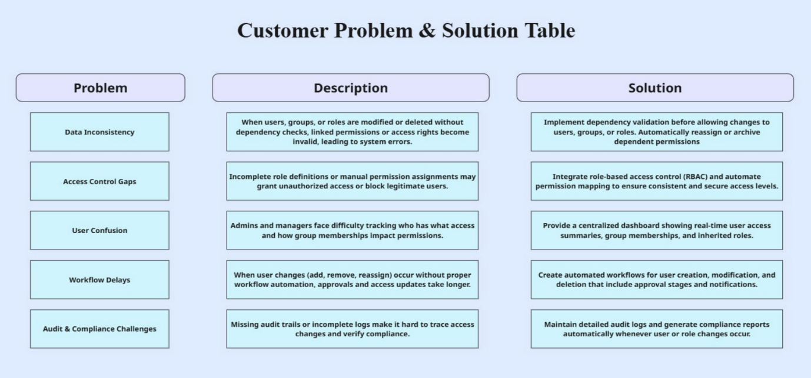

Reference: https://miro.com/templates/customer-problem-statement/

Example:

Problem Statement (PS) | I am (Customer) | I’m trying to | But | Because | Which makes me feel
PS-1 | System Administrator | Update or delete a user’s role | the system doesn’t allow or gives access errors | the user is linked to multiple groups and permissions without clear dependency mapping | Confused and delayed in performing role updates
PS-2 | Security Officer | Review user permissions | I can’t track all access levels easily | there’s no unified dashboard or audit trail of user-role relationships | Frustrated and uncertain about compliance
PS-3 | Team Manager | Assign access to new team members | it takes too long or gets stuck in approval | the workflow for access requests isn’t automated | Stressed and unable to onboard users quickly

✅ Problem Statement PS 1:
As a System Administrator, I am trying to modify or delete a user’s role, but the system prevents me because the user is still linked to multiple groups and inherited permissions.
This makes me feel confused and delayed in managing user access, especially when resolving urgent requests.
It affects workflow efficiency and creates data dependency issues.
A clear validation system with dependency visualization and automated reassignments would help maintain consistency and avoid broken access links.

✅ Problem Statement PS 2:
As a Security Officer, I want to review user permissions across all departments, but I struggle because there’s no centralized dashboard or detailed audit trail.
This limitation makes me feel frustrated and uncertain about system compliance and accountability.
A unified audit view that tracks every change in user, group, and role management will improve transparency and ensure adherence to access control policies.

✅ Problem Statement PS 3:
As a Team Manager, I want to assign access permissions to new team members efficiently, but the manual approval process causes delays and confusion.
Without an automated workflow, onboarding takes longer, and sometimes access is missed or duplicated. Integrating automated approval workflows and role templates would simplify this process, reduce errors, and improve productivity.

